www.planninginlondon.com
Minutes of the meeting on Monday13th June in Committee Room 3 at City Hall The Queen's Walk, London SE1 2AA. Our Host was formally Colin Wilson
Present: Brian Waters (Chairman)
Andrew Rogers: Association of Consultant Architects
Colin Rumsey: (Formerly LB Enfield)
Duncan Bowie: University of Westminster
Jessica Ferm: UCL
John Lett: GLA
Judith Ryser: Isocarp/Ugb/Cityscope Europe
Lisa Fermaner: City of Westminster LB
Michael Bach: London Forum
Michael Edwards: UCL
Michael Coupe: London Society
Nicky Gavron: London Assembly Member (Part)
Peter Eversden: London Forum
Riëtte Oosthuizen: HTA Design LLP
Ron Heath: Living Architects
Sara Dilmamode: Citiesmode
Tim Wacher
Vicky Fowler: BLP Law
Tom Ball: London Forum
Drummond Robson: Honorary Secretary and Robson Planning

Introductions and Apologies.

Brian Waters introduced our speakers: Riëtte Ousthuizen, Planning Partner, HTA Design LLP and Vicky Fowler, Partner at Berwin Leighton Paisner LLP who kindly came instead of her colleague Christian Drage who had prepared a presentation which she used. Riëtte and Vicky
jointly generated the discussion on the New Housing and Planning Act 2016.
Lisa Fermaner spoke about New Neighbourhood Planning and Neighbourhood and Planning Bill.
John Lett set out some of the key planning parameters for any development of policy under the new Mayor, Sadiq Khan.
Sara Dilmamode of Citiesmode talked about the “We Plan London” information service and the thinking behind it.
Apologies were received from Alastair Gaskin (Hon Treasurer), Bob Dolata, Chris Alda, David Bradley, Jonathan Manns, and Tom Ball.

Discussion of Planning Reforms under the New Act. Jointly by Riette Oosthuizen Director HTA and Vicky Fowler.
The following notes try to combine their two presentations which inevitably overlapped but from different perspectives, and the minutes too have some repetition. Duncan Bowie also added some additional material based on his tracking of the Bill.
The Act received royal assent 12th May 2016

Since the Localism Act 2011 (‘devolving planning to LPA’s and communities’):
• Growth and Infrastructure Act 2013
• Infrastructure Act 2015
• Housing and Planning Act 2016
• Neighbourhood Planning and Infrastructure Bill
Consultation on Technical Changes, Starter Homes Consultation, Consultation on Upward Extensions in London, Expressions of Interest in Estate Regeneration etc.
New Homes in England.

Despite the focus in the Localism Act on more power to local authorities and communities, we have seen an awful lot of intervention in the planning system by Central government and they are not finished yet.

Most parts of the Act are coming into force on dates yet to be specified in regulations
Act introduced to:
‘kick start a national crusade to get 1 million homes built by 2020’
‘to give housebuilders and decision-makers the tools and confidence to provide more homes and further streamline the planning system to accelerate their delivery’.

Objectives and the intended effects behind the Act
- Getting the nation building homes faster
- make it easier for housebuilders to identify land which at a local level is agreed to be suitable for housing.
- making it easier and faster for planning permission for housing to be granted;
- making SoS interventions in the Local Plan process smarter so there are more local plans in place to inform decisions.
- Aims to Help more people buy their own home

Starter Homes

First introduced 2014 – home ownership for 1st time buyers – exception policy
LPA legal to promote Starter Homes – plan and decision making
Starter Homes 1st before other forms of affordable housing
It is all in regulations yet to be published and due by 12th July; even the Chapter can be amended...
Industrial and commercial sites – if classified as 100% starter homes, they do not need planning permission, plus no S106 or CIL (although government still to issue regs on the latter).
Policies will need to identify a stipulated % of starter homes
What is a Starter Home?
- New dwelling/part of building not previously occupied for use as single dwelling
- Includes conversions and office to residential*
- First time buyers 23-40; regulations could amend and also restrict to nationality
- Discount of ‘at least’ 20% of MV but no guideline price
- Funded by immunity from S106 and CIL
- New build homes available to ‘qualifying first-time buyers’ at a minimum discount of 20% and always less than £250k outside Greater London and £450k in Greater London
- Regs can amend price caps.
- 5-8 year restriction on re-sales and lettings yet to be confirmed in regs.

Statutory duty on LPAs to promote Starter Homes
New category of affordable housing for purposes of NPPF

Starter Homes Requirement
Draft regulations propose 20% Starter Homes on most residential developments where minimum of 10 units or more than 0.5ha Subject to off-site commuted sums where LPA approves
These requirements must be met or application is automatically refused
General viability exemption
Specialist housing exemption, potentially affordable housing led estate regeneration, purpose built student housing, custom build and Rural Exeption Sites
Regulations to specify:
- the Starter Homes requirement
- To be secured through s106 agreements
- No specific allowance for local variations in viability but general viability exemption in tightly defined circumstances

Starter Homes Implications
Emphasis on home ownership but what about majority dependency on private rent?
Genuinely wider definition of affordable housing?
Many schemes in London struggle to get to 20% affordable housing (+ effect of dwindling supplies of social rent/affordable rent in favour of shared ownership if developer can afford)
Affordability of the London price cap – need substantial income to access home of £450K
Overall dwindling affordable housing supply as after 5-8 years returns to market housing (together with LPA duty to sell high value housing stock and RP’s Right to Buy)
Largely self-enforcing regime
Sales and letting restrictions
Draft regulations propose sales within specified period of 5 (or 8 years) other than a qualifying first-time buyer subject to a tapered discount

Starter Homes – Secretary of State intervention
Intervention by SoS if LPAs fail to carry out functions in relation to Starter Homes
SoS may make compliance direction where incompatible policies in local development documents directing LPAs not to take into account incompatible policies when taking certain planning decisions

Are Starter homes a boost or blow to housing delivery?
Viability - affordable housing policy and statutory Starter Home requirements to be met – may prevent councils from delivering other forms of affordable housing and home ownership products
Reduction in the supply of other forms of affordable housing?
Affects cash flow
Distortion of market
Regulations yet to be laid means Manifesto commitment to build 200,000 Starter Homes over course of this Parliament by 2020 likely to missed

Custom Build
- LPA keep register of interest in self build and custom build homes
- Sites 1 to 4 units
- LPA duty to ensure sufficient serviced permissioned plots available to meet demand
- Impact on LPA small sites programmes?
- Does it make delivery easier for those interested in custom/self build?

‘Planning permission in principle’ (PPIP) Permission in Principle (PiP) – what is it? Section 150 of the Act
- The grant of PiP either (1) on land allocated for development in ‘qualifying documents’ (eg brownfield register, development plan or neighbourhood plan) or (2) on application.
- It’s not a planning permission – PiP & technical details consent = planning permission
- PiP initially limited to housing or housing led developments

PiP: How it will work? (1)
Three routes by which PiP may be granted for housing:
- For brownfield sites registered by LPAs as suitable for housing
- Nationwide Development Order for sites allocated for housing in Neighbourhood and Local Plans
- Consent grant following an application for PiP granted at time ‘qualifying document’ is adopted or made by LPA and requirements for type and scope of development (to be set out in secondary legislation) satisfied.

PiPs granted through plans and registers proposed to last for a maximum of 5 years, but may be some local variation
PiPs granted on application to expire either after 3 years or 1 year

Pip: How it will work (2)
‘In principle’ matters – core elements underpinning suitability of site for residential development to include:
- Location – redline plan identifying location and site parameters
- Uses – housing led uses, may include retail, community and commercial uses forming part of a housing led development
- Amount of residential development – PiP to specify minimum and maximum level of acceptable residential development
Local and national planning policy must be considered in the grant of PiP and technical details consent
EIA and Appropriate Assessments to be carried out at PiP stage if required

PiP: Allocated Sites in Local or Neighbourhood Plans
Power for SoS to make Development Order granting PiP to land allocated for development in a ‘qualifying document’, which includes Local or Neighbourhood Plans
Development Order to set out what type and scope of development will be granted PiP
Since PiP will identify both the location, use and amount of residential development as well as parameters of the technical details, consent could result in quite detailed plan policies

PiP: Technical Details Consent (1)
Full planning permission granted through technical details consent – PiP to describe parameters for technical details
Technical details may include design, access, layout, provision of infrastructure, open space, affordable housing, site specific matters
Technical details consent may be granted subject to conditions and planning obligations (no conditions attached to PiP)
Principle of development cannot be reconsidered at the technical details stage

PiP: Technical Details Consent (2)
Approved or refused only on grounds of previously unconsidered technical matters – right of appeal
Consultation on technical details not proposed (optional). Public consultation only at PiP stage
Documents: design statement (layout, access & architectural detail) & an impact statement (assessments eg contaminated land, flood risk; & mitigation eg remediation & drainage schemes)

PiP: boost or blow to housing delivery? (1)
- Greater certainty at an early stage about whether land is suitable for development
- Should enable developers to secure funding earlier in the planning process
- Avoids heavy investment in the finer detail of a scheme before site suitability determined
- Multiple assessments of site suitability during planning process avoided
- Leading to faster start to development once technical details approved
- Timing to determination: PiP (minor) 5 wks, technical details (minor) 5 wks, technical details (major) 10 wks

PiP: boost or blow to housing delivery? (2)
- Existing site allocations in adopted development plan documents cannot grant permission in principle, so authorities will need to prepare new planning documents if new sites are to benefit from the proposal.
- There is a need to deal with EIA at the PIP stage. If there are no conditions or section 106 it is difficult to secure the mitigation that make schemes acceptable in environmental terms, at least on applications.
- PiPs still locally driven and it is often the detail on major schemes that removes opposition or concern

PiP: boost or blow to housing delivery? (3)
- In practice brownfield registers do not currently exist so full benefit of measures will take time
- Potential increase in legal challenges – will be important to ensure the impacts are adequately assessed and addressed
- Measures will only apply to site allocations in future plans, not retrospectively
- LPAs not bound by principles of the PiP when determining technical details consent where PiP has existed for a long period and there has been a material change in circumstances (subject to future consultation)

PiP: boost or blow to housing development? (4)
Whether major developments can apply for PiP. Any benefit over outline permission?
PiP/technical details application cost unknown but “consistent with similar types of applications in the planning system”
Unclear how conditions and infrastructure will be negotiated and provided

PiP: mid July; register of particular kinds of land already in force

Other changes proposed in the Housing and Planning Act
- Minor amendments to Neighourhood Planning Process
- SOS step in powers when LPA’s are not preparing local plans fast enough/ Mayor of London powers (already in force) – widened scope of referral and call in powers in relation to local plan progress
- LPA to apply to Gvt (SoS) for a ‘planning freedoms scheme’ – disapply planning provisions to facilitate increase in amount of housing, subject to local consultation
- Financial benefits in committee reports – whether or not material to the application + has it taken into account the Neighbourhood Plan if applicable?
- NSIP and housing (limited to 500 homes initially) e.g. related to HS2 or Crossrail 2.
- Processing of planning applications by alternative providers – not determination (so validation rather than processing)
- PiP (Permission in Principle)
- Wonderful news for those wishing to increase land value, but is it delivery focussed?

Brownfield Registers (1)
Power for regulations to require LPAs to hold and maintain up-to-date registers of brownfield sites suitable for housing
Land must satisfy prescribed criteria before entry onto brownfield register (eg available in near future for housing, capable of supporting 5+ dwellings & capable of development)

Brownfield Registers (2)
Register in two parts:
First part: brownfield land that meets prescribed criteria
Second part: list of land from first part suitable for PiP and which has been consulted on

LPAs to have regard to development plan, national policies and SoS’s advice and guidance before land can be entered on register
LPAs may be given discretion to exclude land from register that otherwise satisfies criteria
LPAs expected to include all sites considered suitable irrespective of their planning status
EIA and SEA considerations

Brownfield Registers (3)

Register entries to include:
Site ref / name / address
Estimate of number of homes the site would support (preferably a range)
Planning status
Ownership
“any other information considered useful” eg site constraints and site history

Centralisation of Intervention
SoS’s power to intervene in neighbourhood planning
Step-in powers for SoS in making of development plan documents (used in May 2016 for first time on Birmingham Development Plan because of revision to Green Belt boundary)
Planning applications can made directly to SoS if LPA designated for poor performance

Centralisation of intervention: boost or blow to housing delivery?
Step-in powers for SoS in making of development plan documents used in May 2016 for first time on Birmingham Development Plan because of revision to Green Belt boundary to allow 6,000 new homes
Local Plan approved by Inspector following inquiry
SoS Direction prevents adoption until resolution

Inclusion of ‘related housing development’ in Development Consent Orders (DCOs)
Power for SoS to grant development consent for housing linked to NSIP application
DCLG Guidance to set out details
Draft Guidance issued: related housing should be within a mile of the NSIP or have a functional or geographical connection to NSIP; maximum amount of housing is 500 houses

Inclusion of ‘related housing development’ in DCOs: boost or blow to housing development?
Housing limits set out in guidance rather than statute so can be easily changed
Proposed limits on housing set too low to be significant
Requirement for link to NSIP may be difficult to satisfy in practice

Section 106 dispute resolution
Framework powers for s106 dispute resolution mechanism
Applicant or LPA may trigger mechanism
SoS to appoint person independent person to determine dispute who will make a binding recommendation on appropriate form of planning obligations to impose
LPA then unable to refuse application due to inadequacy of obligations

S106 dispute resolution: boost or blow to housing development?
No right of appeal
Detail deferred to secondary legislation
Could encourage parties to reach agreement independently

Discussion
No-one around the table could see this piece of legislation as likely to result in more housing in London, with the prospect of a widening shortfall of housing supply and the prospects of greater housing shortage. There was general incredulity verging on disbelief that this legislation would be other than add to the confusing overload of regulation burdening the statute book, and increase the likelihood that building will take place more slowly than ever, and certainly not encourage London’s growth, albeit that it could possibly facilitate urban extensions outside London. There was little hope that the forthcoming regulations would generate any simple clarity either.
As usual there is far too much emphasis on process at the expense of understanding how to achieve worthwhile outcomes.
It seemed worth asking why this legislation had been enacted at all, taking extensive Parliamentary time only to make development planning more opaque. Clearly it is not likely to result in more home ownership. Is it that planning and its realisation have become too complex for the law makers ? or the unrealistic belief that planning is simple enough and should be undertaken by lay neighbourhoods without the need for professionals? More cynically is it even a raid on local authority funds?
Planning permission can be refused if not meeting 20% target starter homes. This will disregard any assessment of evidence of need.
Starter homes first, other forms of affordable housing will be considered next. What will happen to other forms of affordable housing. Can starter homes be considered affordable housing?
Includes conversions and office to residential schemes – many are substandard and can now be sold as starter homes as well
First time buyers between 25-40 (regulations can change this age bracket and restrict to nationalities). Caps at 450,000 in London, 250,000 elsewhere. Will this apply across London no matter if a penthouse flat vs a studio flat? And will 250k apply across the whole of the UK?
Median salary in London is £30K whereas the average house price is £530K or more than 17.5 times annual salary. Clearly starter homes will create many cash flow issues.
In case of joint ownership, is it okay if just one of the parties is under 40? Parents buying for their offspring? What if people accept a ‘gift’ towards deposit? Is this okay? Subsidy for UK nationals only? How is this workable? What about one half of the couple?
On sale, after 5-8 years, can revert to market housing. In long-term, loss of supply of housing that is affordable.
Ability to sell at market value has not been explained yet. Government to say no automatic release to the market. L.As to be responsible for lifting restrictions.
In neighbourhood context, neighbourhood is losing out (and subsidizing) because developments not paying S106/CIL for infrastructure/extra services.
All sites over 0.5Ha. Qu for clarification: could LPA ask for less than 10 homes to be eligible – decided locally? Will estate regeneration schemes be exempt from starter homes requirement? This would interfere with LA housebuilding programmes.
In terms of build to rent in the private renting sector there is likely to be commuted sum requirement.
Implications?
Cultural shift towards home ownership rather than rent. Question of affordability. Many people can’t access home ownership and are dependent on private rent. Will exclude a lot of people.
Many schemes in London struggle to get to the 20% affordable housing requirement. If there will be an emphasis on starter homes, we will see dwindling of affordable housing supplies.
How will regime be enforced? Central Government? Unlikely. Idea is that LPAs should monitor and report on how many starter homes will be delivered. Government to step in if LPA is not fulfilling its duties. Where local plans are not consistent/compliant, there may be interference from SoS.
Housebuilders don’t like this – what it is doing to their schemes and cash flow
What happens when it is public land? Exemption for LA estate regeneration, but not otherwise.
Provisions for starter homes – but has not come into force yet.
Concern about distortion of the market, slowing down housebuilding.

Now in a position where we have lost all public subsidy, starter homes requirement and other planning changes in the Act which will reduce ability to secure S106 and CIL. What are chances of Khan achieving much in the way of affordable housing?

PiPs
2 types
Allocation PiPs – for land allocated in qualifying documents, including brownfield land register, DPDs, NPDs. Could take 18 months to 2 years to prepare and approve qualifying documents.
Application PiPs – application to LPA. Lasts 3 years.
What is the advantage?
Most schemes get stuck at the design/technical stage. This won’t help.
Goes beyond an allocation in a local plan – can specify a few more things. Cannot have S106 conditions attached to it.
How does it differ from an outline planning application?
Can’t allocate a PiP unless an EiA has been done already. So why not just prepare a planning application with the full suite of documents required.
PiPs settle the.Number of units and ‘use’ only. Without design detail, this is likely to be underambitious in terms of delivery of numbers. Local communities likely to reject unless the design solves issues of concern.
Consensus: not likely to be used much in London. Perhaps in an urban extension context. LPAs not likely to have the resources for doing PiPs on infill sites. Expectation is that infill sites would get permission for housing anyway.
Huge area for JD and challenge from communities that impact has been assessed
This should not affect estate renewal.
Shouldn’t be putting sites on the brownfield register if they are ‘zoned’ for employment in the local plan.
Definition of a high-value property not yet decided. Will government determine this locally? By postal code or local authority? Will it reflect property type?
The London Plan should balance spare B1, B2 and B8 activity more flexibily.
Neighbourhood Planning
Lisa Fairmaner Head of Spatial and Environmental Policy from Westminster gave an overview Timescales for LPAs to respond (in Planning Act) IS rational
It will be interesting to see what comes up in Neighbourhood Planning and Infrastructure Bill
Relationship with Council’s statement of community involvement would be useful
Clearer guidance on what stage you might attribute weight to a NP in the various stages of preparation. Pre-examination stage?

CLG is interested in the idea that NP might include a project list in appendix that might help with S106 negotiations
We’ve asked for legal duty that no neighbourhood plan area should be disadvantaged.
Should be a duty on LA to support NP. But there are no resources for LPAs to support NPs, and this restricts support that LPAs can give. Will the
Neighbourhood Planning and Infrastructure Bill deal with thorny issue of degree of conformity with core strategy? Independent examiners are all over the place in terms of how they decide on NPs
Asked if a ‘duty to cooperate’ would help? LF thought not.. Lots of groups form NF just so that nobody else will. Or they form one and then don’t progress. Would be a waste of LPA resources.

SaraDilmamode, Citiesmode. Project: “We Plan London”
See http://weplanlondon.com/
SD explained that this was a New planning, information and training site.Born out of frustrations, such as repeat tasks. Explaining acronyms. Opacity a problem in planning
Getting [new thing] done. Eg CIL. How do you fill out CIL forms?
What does it include?
‘Planimations’ – e.g.
http://weplanlondon.com/explain/planimation-planning-applications/
http://weplanlondon.com/explain/planimation-the-development-plan/
Collate useful resources. E.g. QUOD’s CIL map
Useful Talks
Planning TV – bitesize planning discussions/panels
What next?
- Planning perspectives- public/private sectors
- Short bite-size courses on ‘how do you do X planning thing’. Use the YouTube model.

John Lett, Towards a new London plan
Briefing on pressures for growth. Do not yet know what Khan’s response will be.
No deputy mayor for Planning as yet.
James Murray is deputy mayor for housing, currently covering planning.
Speedy review of 2011 plan underway
Due diligence work on NPPF requirements underway.
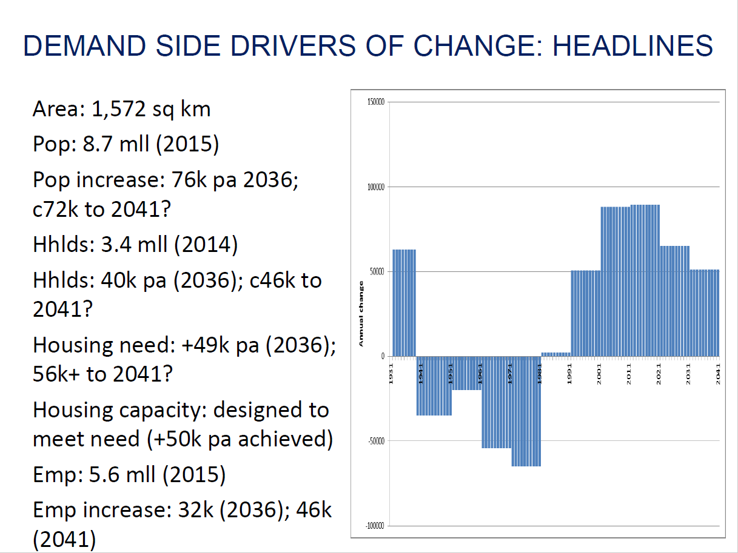

Housing:
Population projections coming out with similar figs to further alterations. Approx. 76k p/a increase to 2036. C72k to 2041. Recent growth not just a ‘Blip’ – seems more long term.
Hhlds: 40k pa (2036) c46k to 2041?
Translate to housing targets? Rule of thumb to handle backlog, add another 10,000. i.e. 56k pa target housebuilding.
Local plan expert group – using different methodology. Could give us a bigger number of 75-80k target. We think our approach is more robust. Strong reservations about CLG approach.
Trend based population growth in outer London.
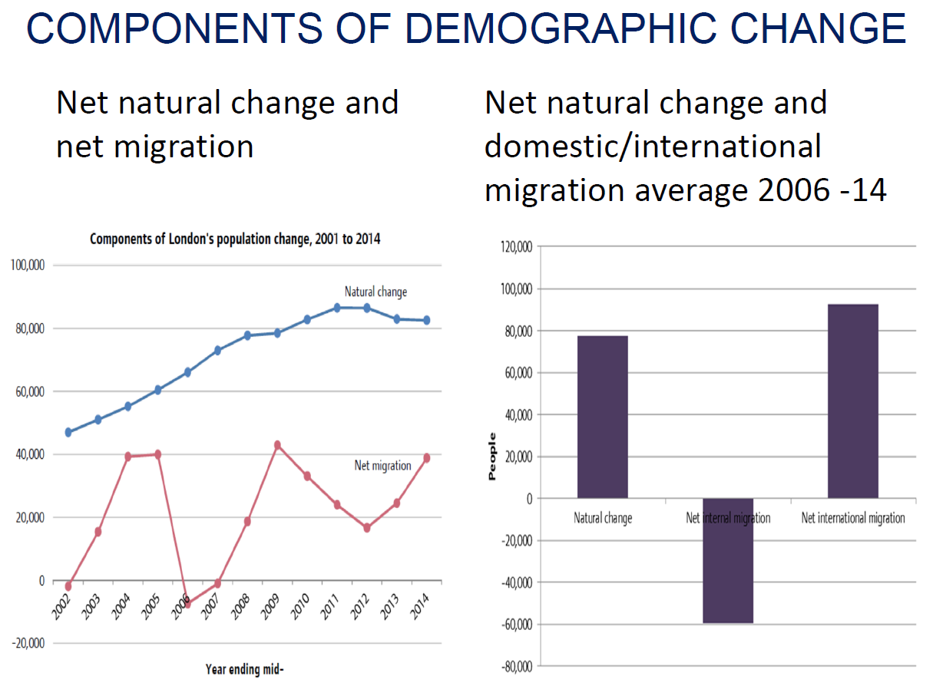
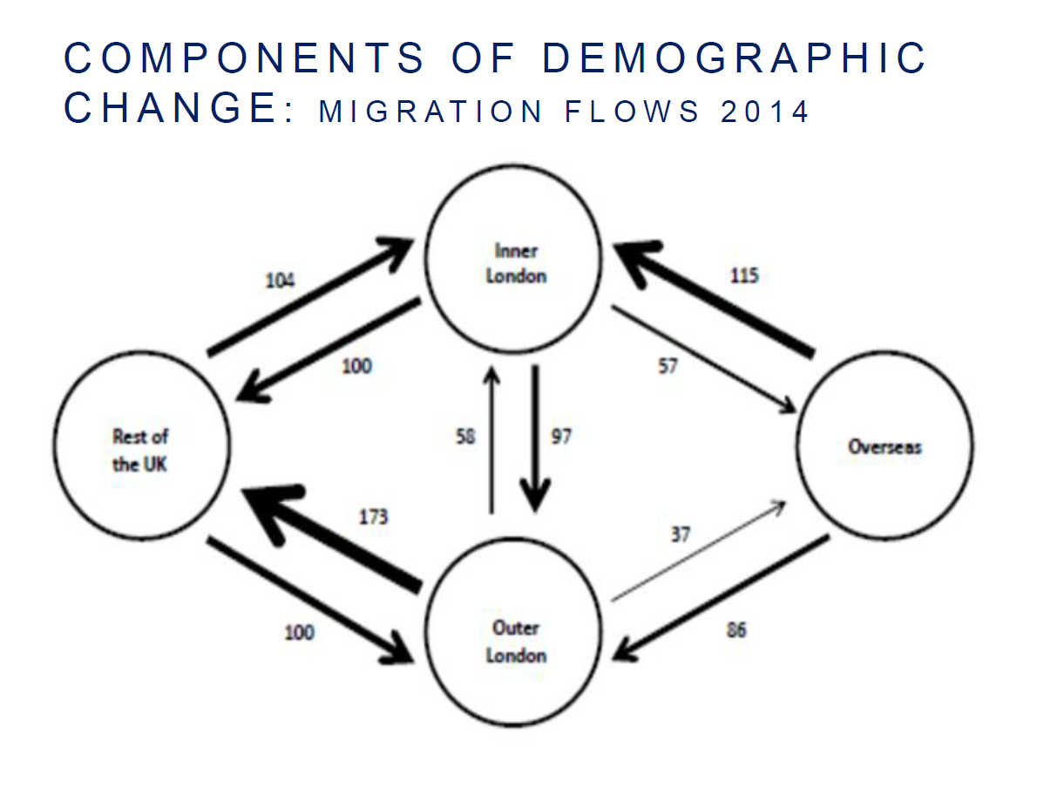
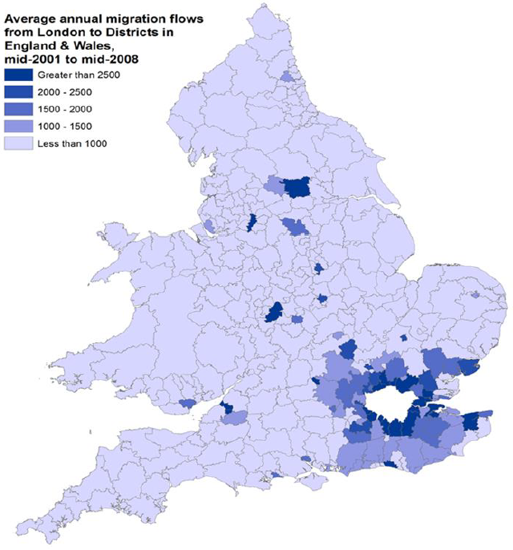
Net Average annual Migration Flows in England and Wales Mid 2001-Mid 2008
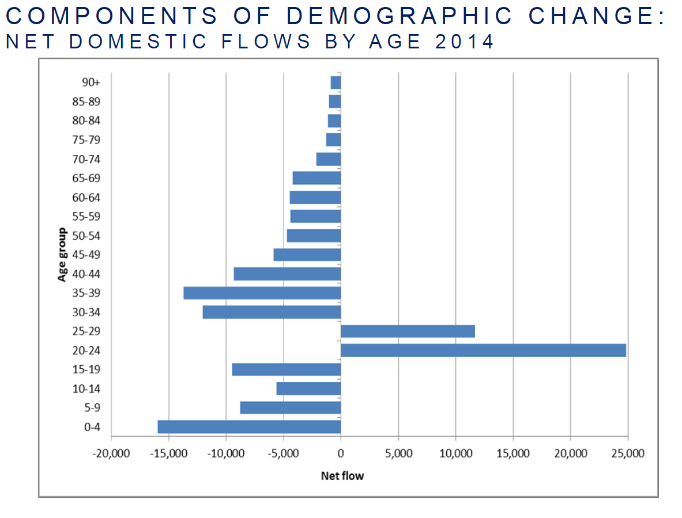
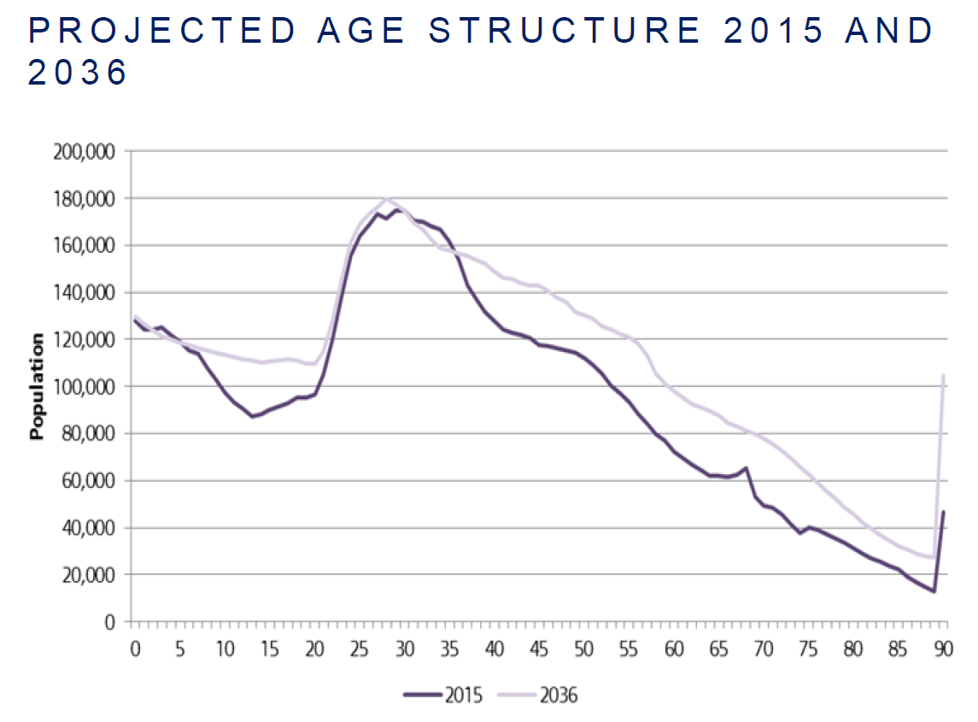

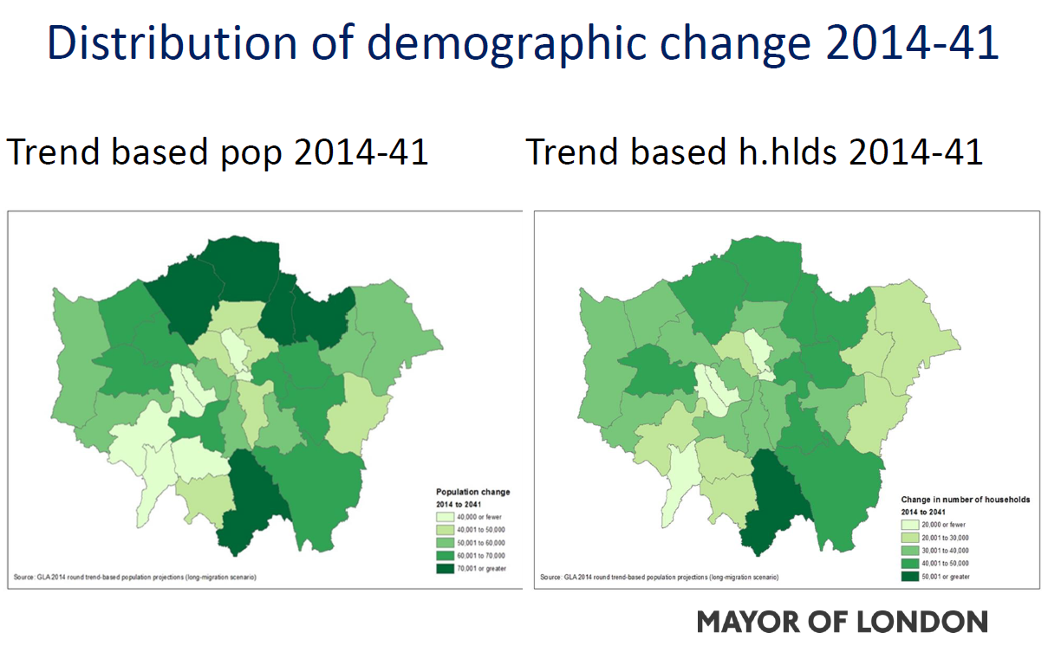Employment:
4 to 5 independent bodies that have profound employment projections. 700k jobs since last recession. 100k a year approx. (now abating). We take a long-term view of employment growth. Long time series backwards.
Main growth is in ‘professional, scientific and technical’
Meeting wider SE at end of the week to talk about implications of housing need being accommodated outside London borders
People who move out tend to be families. Older people moving to the south coast – numbers are not that great. Big question – will ageing population stay in London?
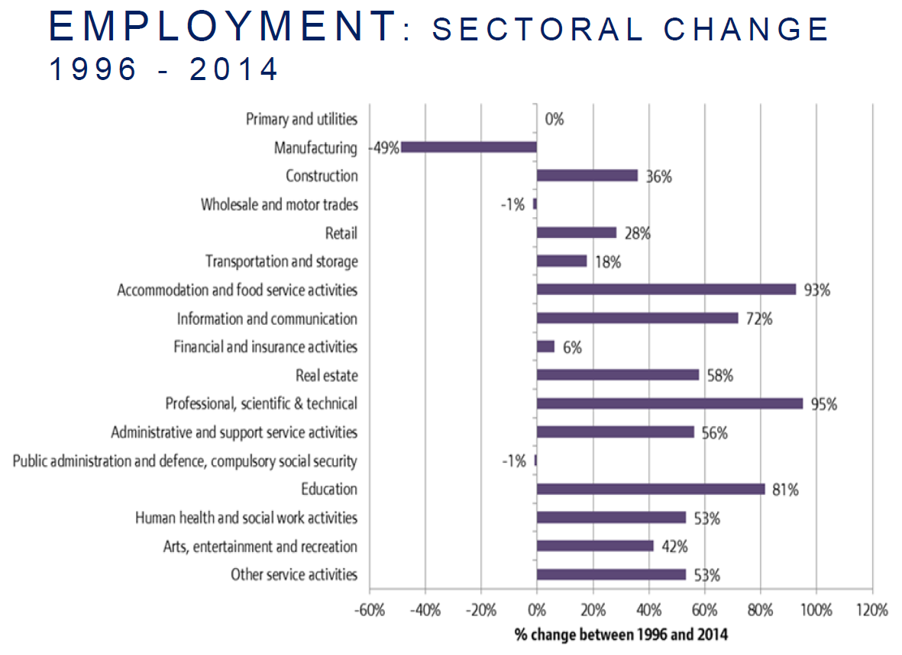
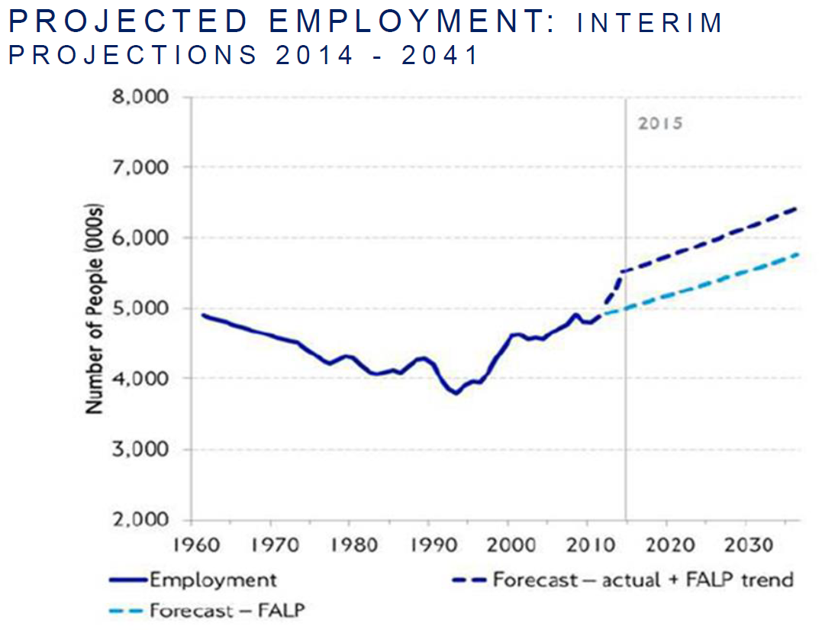

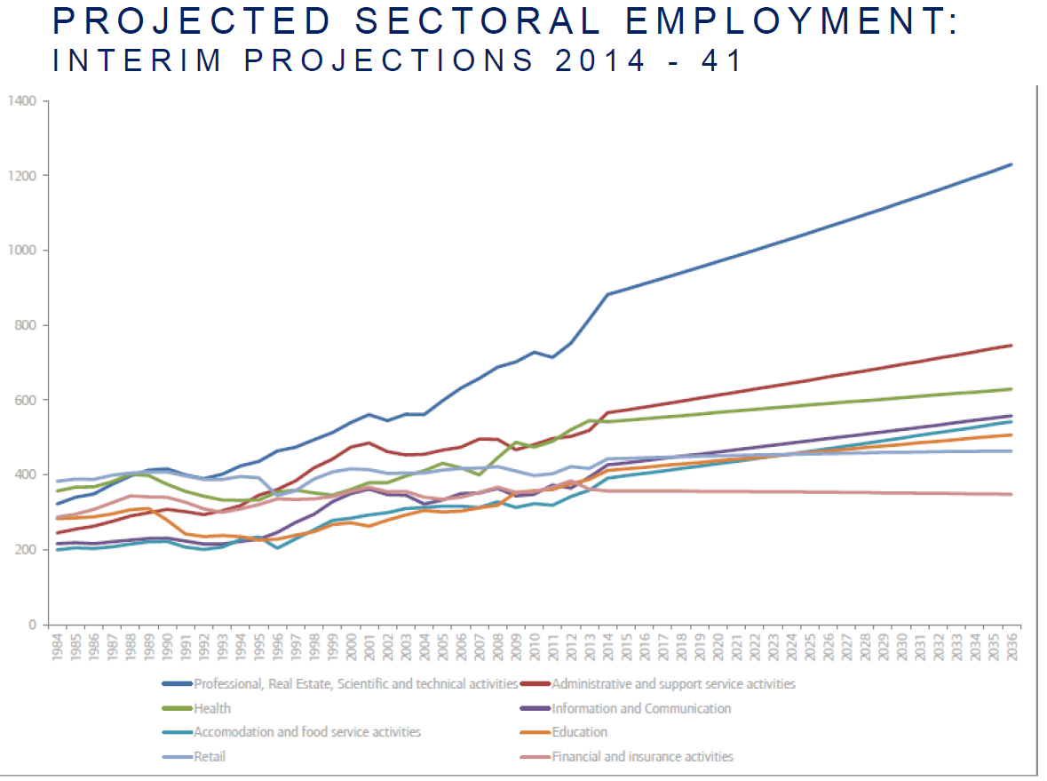
Possible supply side options:
- trend based scenario – agglomeration
- town centre intensification. Major viability issues in knocking down and building at higher densities. Mayor is keen to retain ‘character’ of existing town centres. English Heritage has done some work – 60-70% town centres have some conservation protection.
- intensification around PTAL (does not take into account Crossrail 2)
- suburban intensification – this option could deliver significant growth
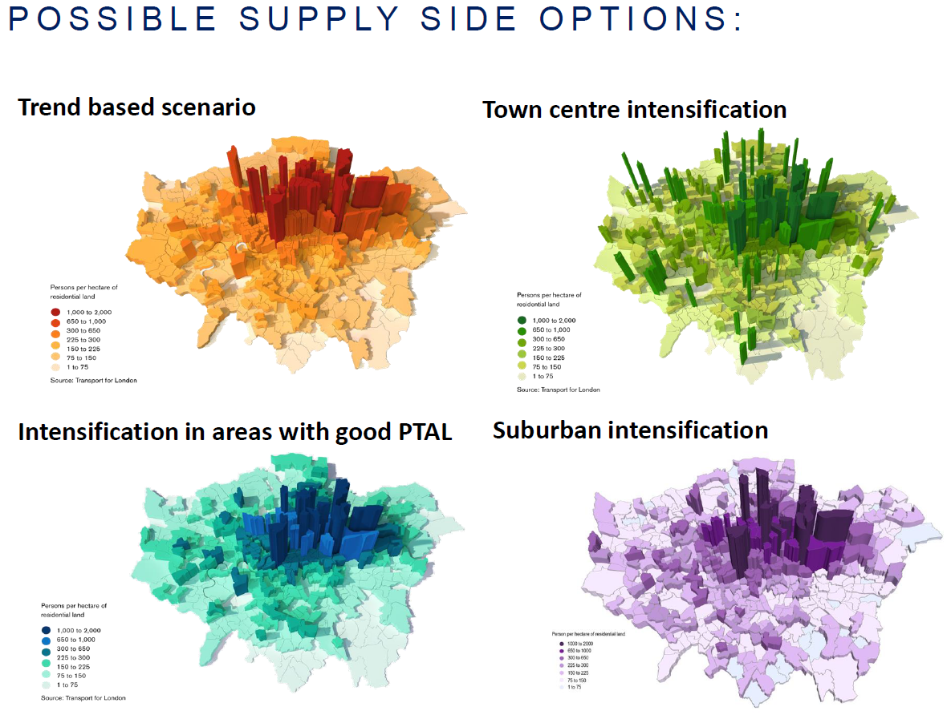

Other supply side options:

Industrial co/relocation: Should we continue existing loss? We have 7,000 Ha left, should be losing no more than 40 Ha a year, mostly in the East. We’ve been losing 2-3 times that amount though. Issue then is - are those benchmarks wrong? Could they be more generous? Does a big postindustrial city like London need industrial land? It is affordable business space really, not smokestacks. Could we relocate outside London? Discussing with wider SE. Will express views to new Mayor in July.
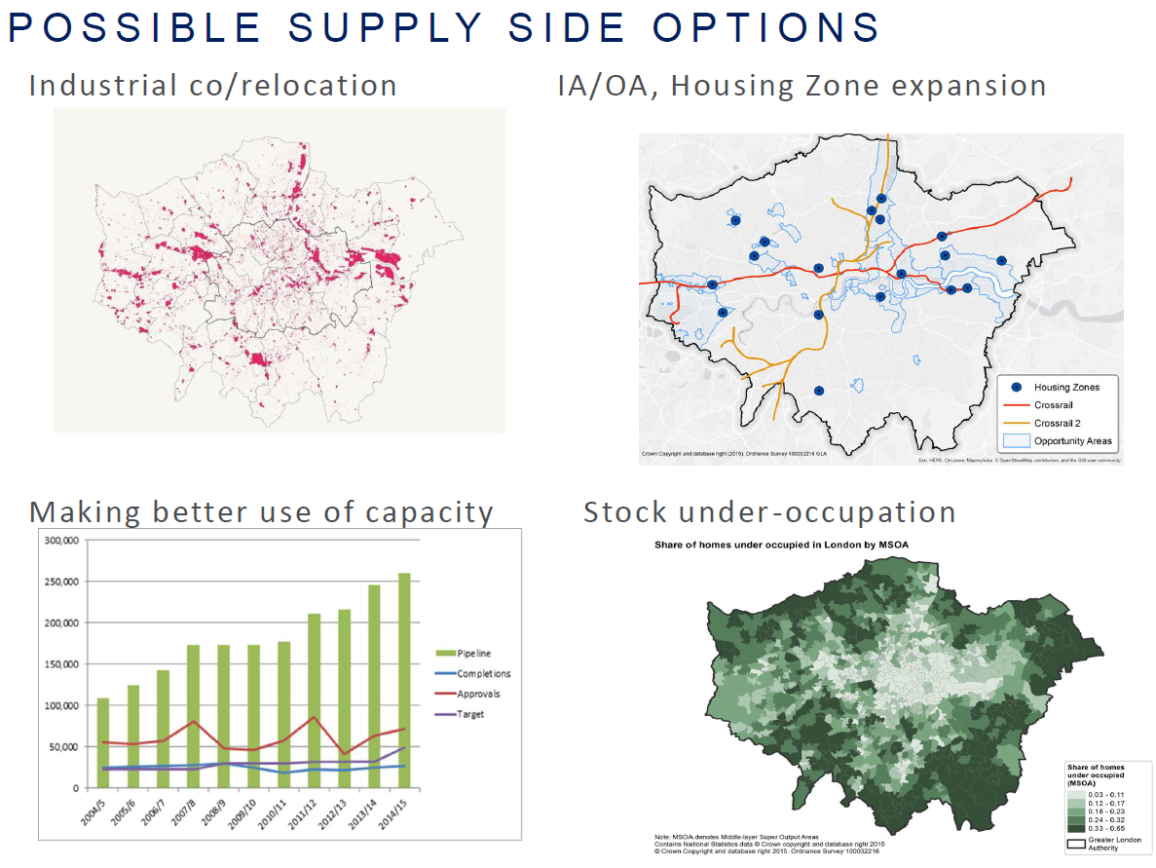
IA/OA, housing zone expansion: Why are planning approvals in pipeline not being translated into completions. Not just planning’s fault. GLA officers think more complicated.
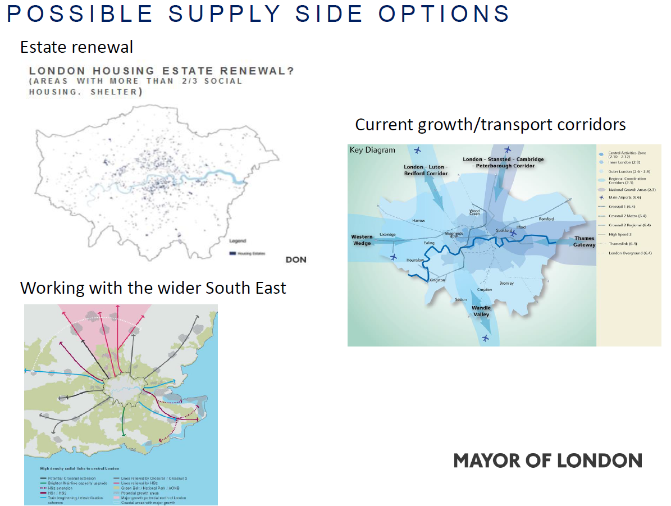
Estate renewal. Government very keen – Lord Adonis promoting. Takes a long-time to realize.
Working with the wider SE. Growth/transport corridors. Urban extensions, town centre expansion focused on deprived towns, new towns/garden villages. Fare structures/travel costs need to be considered to incentivize commuting.
Composite supply side options. Crossrail 2, bakerloo line extension. Scope for further intensification/renewal.
No ref to green belt – mayor has made his position clear on this. Some tough choices will need to be made.
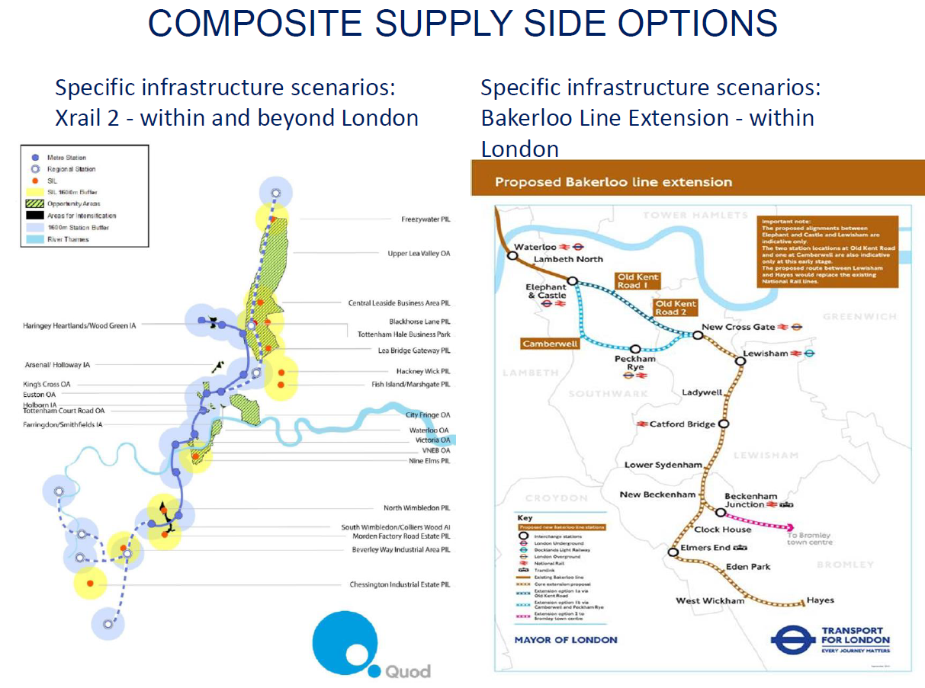
Next steps:
Informal consultation- autumn 2016
Consultation on full draft – Autumn 2017
EiP – summer 2018, Adoption: Autumn 2019

Questions:
Match between where capacity is and where population trend growth is (outer London).
Strategic land availability study required - devil in the detail
Is this mayor asking: what kind of London do Londoners want to see?
ME: When is assessment of options and environmental impact going to take place?
John: CASA model and TfL’s Lonluty(?) model should do this.
Nicky G: growth of employment hubs outside London, as well as housing? Reverse commuting.
John: One of TfL students has done a good piece of work on this: 274k a year going out, 789k a year coming in. Current status unknown.
Nicky – what about projections in the future?
Other Matters

- Minutes of the Meeting held on Monday Monday 21st March at The University of Westminster 35 Marylebone Road London NW1 5LS. Our Host was Duncan Bowie.
These were accepted

- Treasurer’s report.
None.

- Next Meeting
Next meeting at UCL on 14th September our host is Michael Edwards. The room is
LG01, Central House, 14 Upper Woburn Place WC1H
5. AOB
London Forum: 19th Sept, (after Forum?) 6.30pm –event on likely impact of legislation and changes. At The Gallery, Cowcross Street.

