www.planninginlondon.com
Minutes for the Meeting on Wednesday 9 September in Committee room 4 at GLA City Hall The Queen's Walk, London SE1 2AA between 2.30 and 5.30pm. Our host was Colin Wilson, Senior Manager - Planning Decisions.

Present:
Brian Waters: Chairman
Alastair Gaskin: London and UK Property
Amena Matin: London Land Commission
Andrew Rogers: Association of Consultant Planners
Brian Gatenby: Get Planning
Duncan Bowie
John Lett: GLA
Jonathan Manns: Colliers International
Lisa Fermaner: City of Wetsminster
Matthew Waite: GLA Economics
Michael Edwards: UCL
Martin Simmons: for TCPA
Nikos Karadimitriou: UCL
Peter Eversden: London Forum
Ron Heath: Living Architects
Tom Ball: London Forum
Drummond Robson: Honorary Secretary and Robson Planning

- Introductions and Apologies.
Apologies were received from Brian Whiteley, Colin Wilson, David Bradley, Jessica Ferm. Judith Ryser, Paul Finch, Roy Pinnock and Will McKee.

- DISCUSSION TOPICS
- Outer London Commission Update.
The topic was introduced by Peter Eversden. Will McKee was unable to be present. PE explained that the Outer London Commission (OLC) had been established 6½ years ago to assist the Mayor in forming strategic policies for the London Plan. Outer London though mentioned in 2004 was not being implemented in practice. A new relationship has been developed with the Outer Metropolitan Area and a greater partnership with Outer London Boroughs. Each of the 4 sectors (North, East, South and West) operates differently. The Common approach is to ask questions of the Boroughs to reach common understanding.

In some areas such as the London Land Commission there has not yet been participation but some of the OMA recommendations have become policy in the 2011 Plan., such as opportunities for strategic development e.g. aeronautics and films, although as yet little has been achieved. A promise to assist the work of Boroughs has yet to be effective. Shopping and Town Centre changes have been clarified, notably links with transport infrastructure and the next alteration is expected to incorporate these as part of guiding what happens in Town Centres.
Small and Medium Enterprises have been losing ground in the areas around town centres as the result of the application of Central Government residential conversion policy. PE considered that DCLG does not appear to understand the harm this policy is doing in London which takes away all the exemptions that local authorities earned for themselves. This is in spite of the contrary unanimous views of the Assembly.
It is claimed that 6,000 new homes have been delivered but PE thought this was not so. Offices to residential is not delivering. Government also does not appear to like the adopted housing planning and parking standards. Housing Minister Brandon Lewis in particular appears to be against GLA Planning. This has resulted in alterations following further alterations to the Plan. New policies “shall promote relaxed parking standards. A new Plan is now being pursued. The Duty to co-operate is being pursued more vigorously.
Boroughs are responding to the housing crisis. The minimum requirement is 62,000. 28,000 are being built. The target is 62,000. There is uncertainty as to whether the targets will be met. Ed Lister is responding to this issue. Discussions continue with Rest of SE England groups. The objective of new development along growth corridors is being actively pursued by the Chancellor, although the principle of not reintroducing SERPLAN remains in place with Boroughs disagreeing. 4% of green belt is needed to provide 250,000 new homes if the infrastructure is in place. There is a meeting next week of home counties local authorities.

Discussion. The Chairman thanked PE for his synopsis. He asked about secretarial and budget for the Outer London Commission. Some people are appointed by the Mayor and this is augmented by officers from the London Plan Team. The Mayor is clear that no green belt should be included for new development but this has not precluded thinking of Green Belt options.
PE was critical that ideas from Central government have been put forward without proper impact assessments, notably on the take up of empty offices.
Michael Edwards asked how the OLC can contribute to employment, given that industrial space is constantly under pressure to be used for housing. PE suggested that greater use needs to be used for small industrial activity in areas around town centres.
Duncan Bowie added polycentric growth objectives and suburban growth corridors. He also said it was not just housing numbers but for whom and what kind of housing. Does it include affordable.
PE responded to say that Outer London is dominated by family houses with gardens. He thought that affordability is not understood, while others are keen to develop what they can. Housing Estates are being handed to developers bringing displacement and gentrification. Schemes in Greenwich and the Elephant and Castle Heygate scheme have lost 8-9,000 social rented units. The s106 requirements now preclude providing adequate affordable housing on viability grounds.
BW asked what was wrong with 6,000 more homes.
John Lett said that the long term trend is for 2-3,000/year. He cited the constraints set out by Molior: • Control of the ‘realistic’ pipeline, • Non-balance-sheet funding, • Private sector capacity, Public sector speed and consistency. He said that some 19,000 of approved schemes were under currently construction.
BW referred to Martin Goodall’s Blog of 8th September:
This says” Since July, when the government pulled an expected announcement almost at the last minute, there has been feverish speculation as to when the government will announce its expected extension (or removal) of the deadline for the residential conversion of offices under Part 3 Class O, and the likely extent of this freeing up of the rules, including the new safeguards that may be introduced in the form of additional matters to be considered by a local planning authority when determining a prior approval application in respect of this type of development. All residential conversions of offices under this provision are currently due to be completed no later than 30 May 2016, but funding for such developments has all but dried up, because lenders fear that developments that are not already in train may not be completed by the deadline.”
PE said that local authorities would like to use article 4 directions but this is likely to take 18 months or more to be approved which goes beyond the current deadline.
BW said these issues were cyclical and that workspace will no doubt become more valuable again. Planning always needs a time horizon to deliver to.
Lisa Fermaner said that the business sector too is affected by this, not just local authorities. It notably affects West End small and specialist business clusters.
Drummond Robson was puzzled why Central Government appeared to be promoting such unpopular ideas at all.
DB suggested it was due to a the lack of Civil Service knowledge and experience, and questioned whether the majority are qualified. Steve Quarterman is leaving for the Planning Inspectorate. Too many cases are leading to Judicial Review while Ministers go ahead regardless.
BW thought this may be a matter for think tanks to consider.
PE commented that an all-party Parliamentary group has been established for London led by Bob Neill. Its work will proceed through select committee to establish the truth rather than what whips tell them. Jonathan Manns disagreed saying the group is not interested in the Built Environment but in fiscal and devolved power.
Lisa Fermaner thought that the obstacle would be the greater influence of the development sector.
ME said he was not surprised at the Committee situation. The root of this is that there are incompatible groups of people in the Conservative party with backgrounds in corporate affairs, money etc. which do not relate to affordable housing objectives with the result thatb they are producing contradictory policies.
Amena Matin said it was not necessarily all about building houses. Plainly policy is not working. We need therefore to pause and reflect how to get land into development.

- Update on the London Land Commission. Amena Matin, GLA.
The Chairman welcomed Amena Matin senior manager London Land Commission, and referred the Forum to her recent article in PiL. This explained notably that “The London Land Commission will be tasked with identifying public sector brownfield land which is surplus and could be released by 2025. One of its objectives will be to create a register of all sites in public ownership. This presents a challenge in itself. There is a lack of available data on land owned by public bodies in London. There is also an incoherent approach to the release of public land which has the potential to constrain growth in London, especially where a procurement process has not been undertaken”.

The Land Commission tasked GLA to compile a “register” for all publically owned brownfield assets
Once the data has been collated and analysed to identify priority locations GLA will work collaboratively to identify opportunities for residential development and develop planning and disposal strategies, including reviewing exiting practice to establish the best procurement routes.

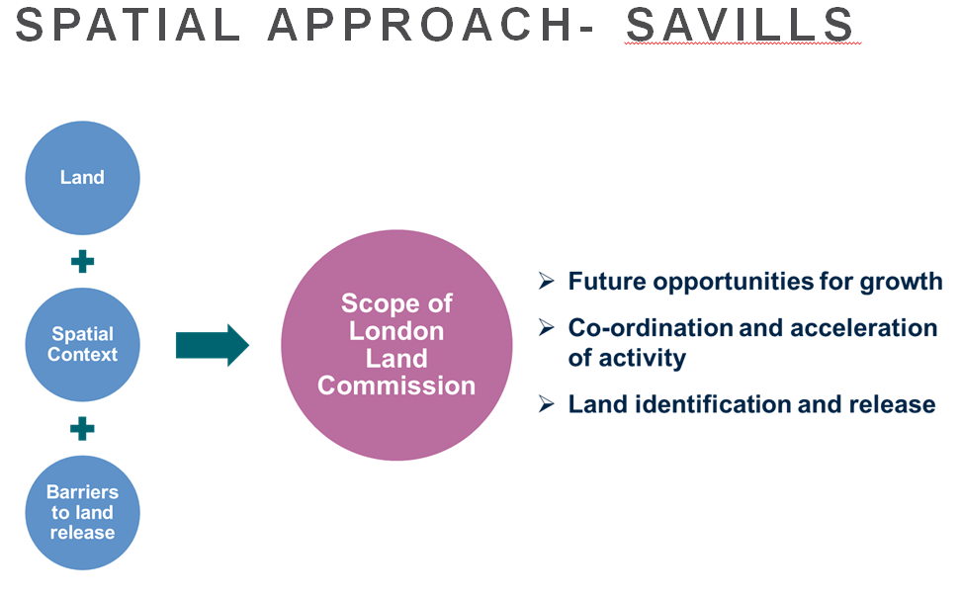
Implementation
The Strategy for land release seeks to address where do we want to Build homes?
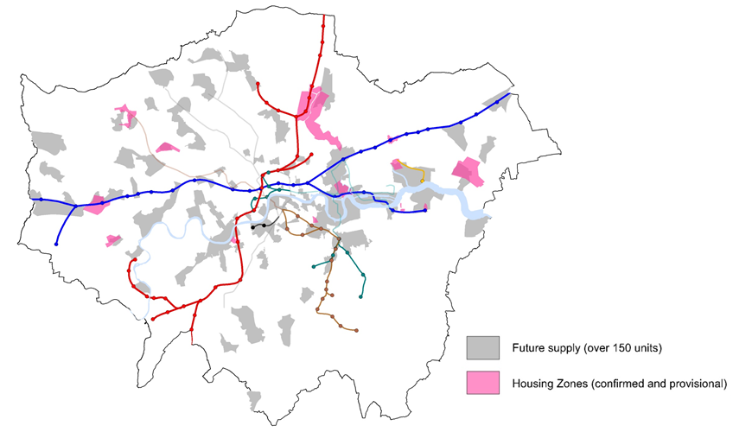

The focus is on additional public sites with housing growth potential (priority over next 5 years)
Focus in policy zones – housing zones and opportunity frameworks and schemes linked to key public transport corridors as above.

Can we support borough owned land to come forward? Is there a enabling or brokering role for the GLA with other public and private land owners? The LLC has started a proactive discussion with Network Rail and NHS estates to work with them and notably to identify quick wins. estates.

Priority opportunities include strategic sites and clusters of sites in the public sector, enabling land assembly (brokering negotiations/deals) and acquisitions. The more specific work of GLA is in providing technical support, procurement and acquisition.
The Strategy for land release is to
Establish comprehensive development strategies including:
Land assembly
Land Appropriation
Remediation/enabling support
Procurement (e.g. London Development Panel)
Planning parameters

Agree a protocol between landowning public bodies for opportunity areas identified to ensure collaborative working and deliverable proposals
Recommendations on addressing barriers and levers required to unlock identified opportunities with Central and Local government commitment.

Next steps
Boroughs to provide GIS data to Savills by mid- Sept
Assessment of public land ownership and site opportunities and the interventions required to enable sites to be released and developed
Consider detailed analysis at Commission’s meeting (end October) for ‘quick win’ opportunities to bring forward sites for development
AM concluded by asking what are the challenges or opportunities? And How do we identify 10 opportunities?

Discussion
Duncan Bowie asked about the numbers involved and what the compliance mechanisms are for selling sites. Under the previous administration dwelling mixes included affordable housing provision.
AM explained the LLC does not replace the planning policy or displace what boroughs may already be doing. The aim is less to seek maximum receipts but to ensure sustainble growth through maximising land uses and intensification across public sector assets.

The GLA model for disposal is always to agree a planning brief with the appropriate local authority,. . all development agreements include overage provisions which are monitored throughout the development as the GLA retains its freehold and disposes on a long leasehold basis.

Jonathan Manns asked more detail about lease principles comparing how the Great Estates operate on the basis of 125 year leases. AM confirmed that the principle of placemaking and future proofing current surplus sites to encourage sustainable growth is clearly important.

DR was concerned that local authorities appeared not to match housing provision with adequate infrastructure, notwithstanding section 106 and now CIL contributions. Many local authorities have not spent section 106 income and may be similarly not guaranteed to spend CIL appropriately.

PE agreed concluding that there was also little evidence that approved schemes are being built, nor the associated supporting schools etc. being built. He also wondered that without being mandated to do so whether LLC could compel Boroughs to do what LLC tells them.
LLC only has £1m which is restricted for use this year with no prospects beyond this yet.

ME suggested that LLC should publish their findings as an urban database. Local authorities currentlat appeared to be in a fiscal panic and were demanding “top dollar” for all permitted schemes.

AM said that this issue is LLCs principal concern to sell off land at the highest value, since the principle of a worthwhile scheme is actually more important than “top dollar”.

Ron Heath spoke of his experience of shortage of land and Green Belt being met by discounting housing for affordable schemes, but this being overridden by County authorities providing gestures towards Housing Associations , not providing claw back facilities or requiring first nomination rights.
DB reinforced this by saying the objective should be 100% nomination rights, rather than maximum receipts. He asked rhetorically what “best consideration” actually means?

- London Employment Forecasts and Housing/Office Needs. Matthew Waite of GLA Economics.

The Chairman welcomed Matthew Waite from GLA Economics to set out the GLAs employment forecasts, which are a principal source for local authority employment strategies.

- Overview
20-25 years’ time, although trends rather than a forecast
Quick outline of methodology – how we ‘project’ jobs;
Current jobs growth and the ‘productivity puzzle’;
New projections (total, sector and borough);
How confident can we be in the new projections;
Summary.

- Long-term projections
A variable’s history includes the effect of everything that has driven it;
A variable’s history can be the basis of a projection so long as:
It has a reasonably stable pattern and is not random; and,
It is reasonable to assume that future shocks and structural changes are no bigger in the future than in the past – a judgement.

- The variable of interest – jobs
The level of jobs in London is not a random variable;
Jobs growth is arithmetically related to output and productivity changes:
∆ in employment = ∆ in output – ∆ in productivity
That is for growth to occur we either need more workers (jobs) or higher productivity (ie more output for each employed worker).

- Strong labour productivity growth over many years both in UK and London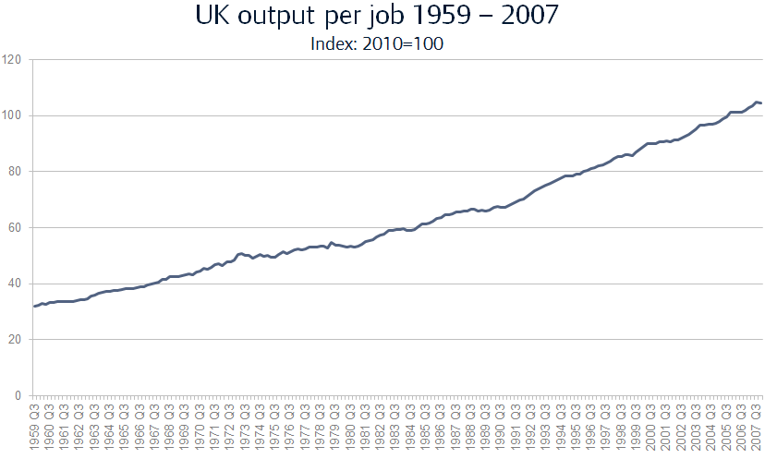

- Productivity and output relationship (London)
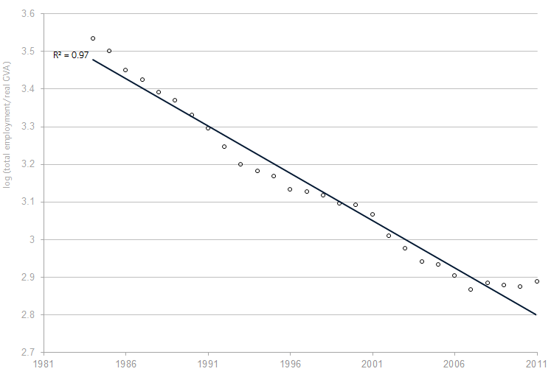

The correlation indicates that for every 1% growth in productivity there has been 2% in employment
- And the performance of projections, over the longer term, is not bad.
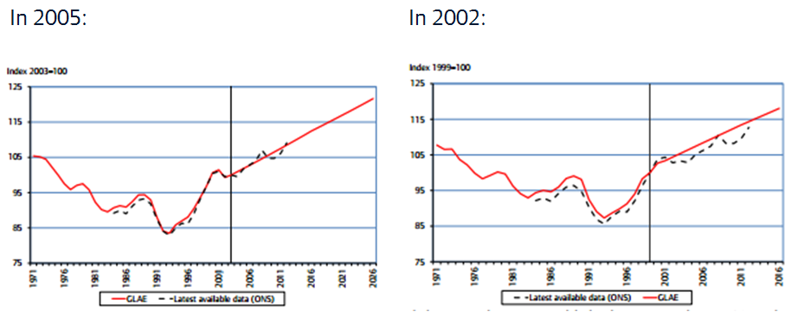
Source: Performance of GLA Economics’ employment projections, Jan 2014, GLA Economics

FALP assumes 2½% annual growth in employment based on Department of Employment projections to produce 5.7 million jobs by 2036.

- Further Alterations to the London Plan employment projection
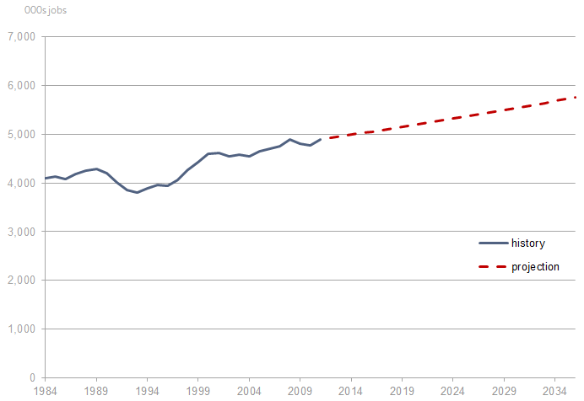
- However, growth in jobs since the FALP projections has been extremely strong …

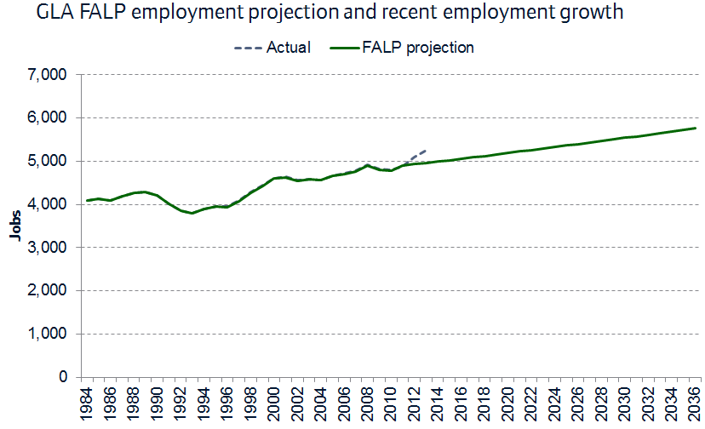

- … because of “the productivity puzzle” …
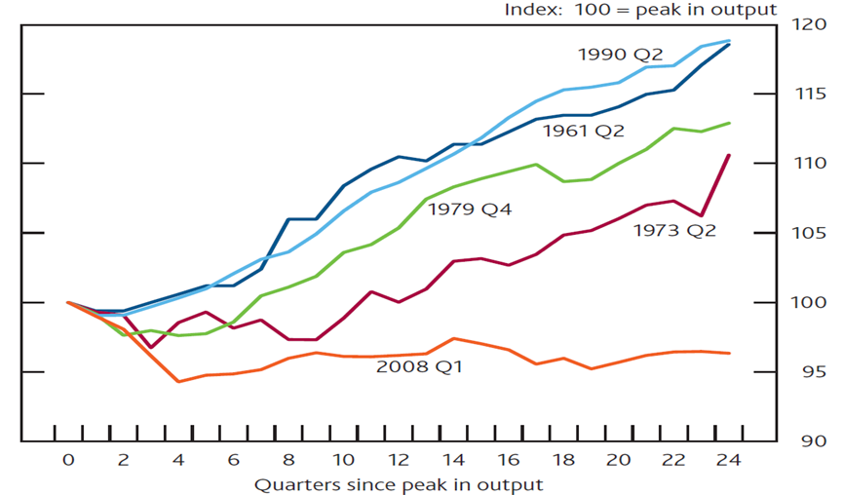

… which has seen productivity growth stall with nowhere near the previous productivity trend line.2008 was quite different from the previous year and 2007-2013 are also quite different, resulting in productivity of 1% compared with 1.3% jobs growth.
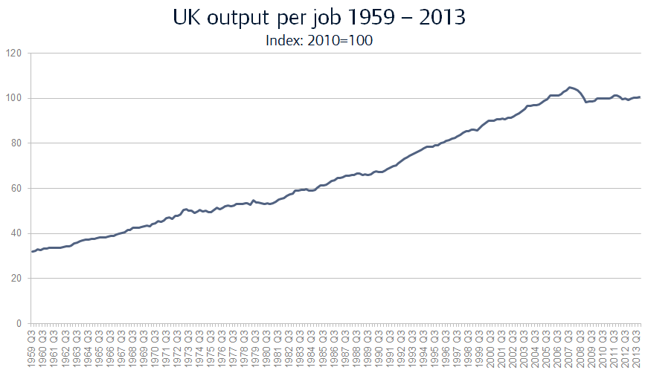

- … puzzling many bodies beyond the GLA!
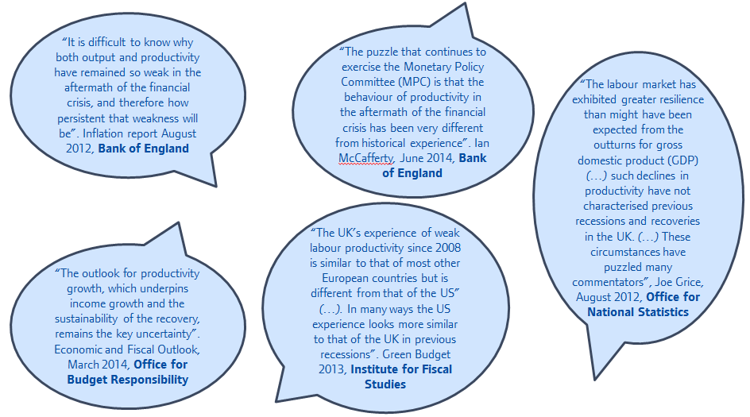

- The new projections show a step change in jobs growing to 6.4 million by 2036...
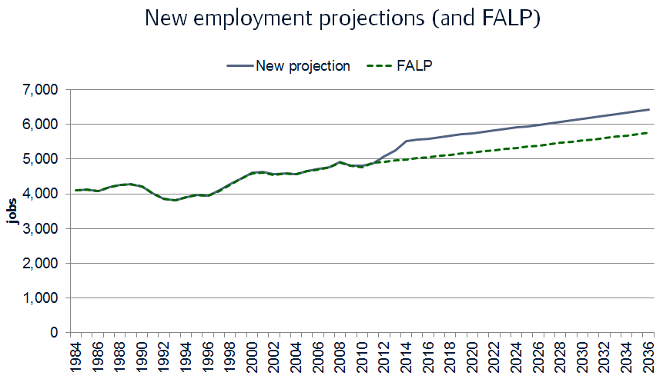

- … with continuing growth in professional business services and some other sectors …
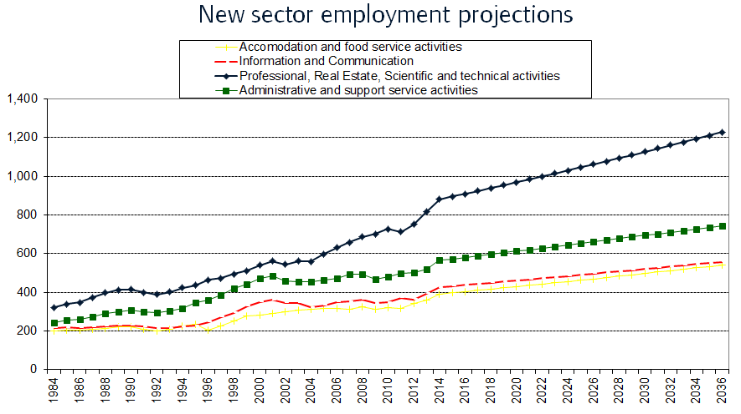
Administration includes temporary security staff.

- … but projected declines in sectors like manufacturing and also some other sectors ...
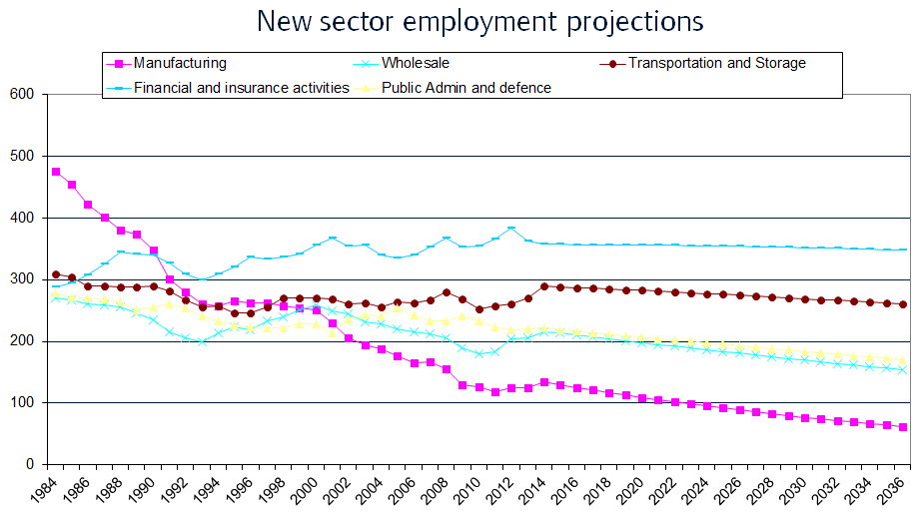

- … with rises in some boroughs (based on past trends only) …

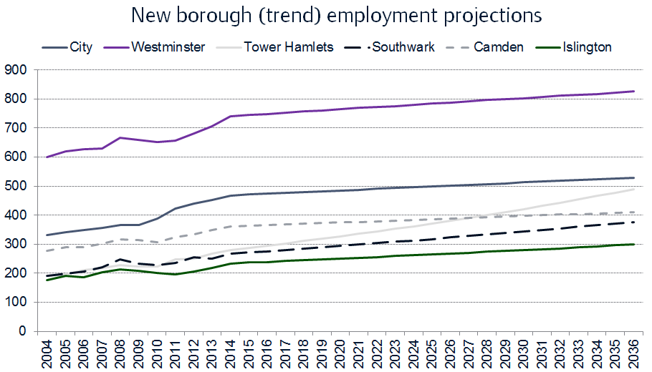

At the Borough level Tower Hamlets shows strong growth if you follow the trend, especially in Canary Wharf and Southwark

- … but with falls in some boroughs (based on past trends only).

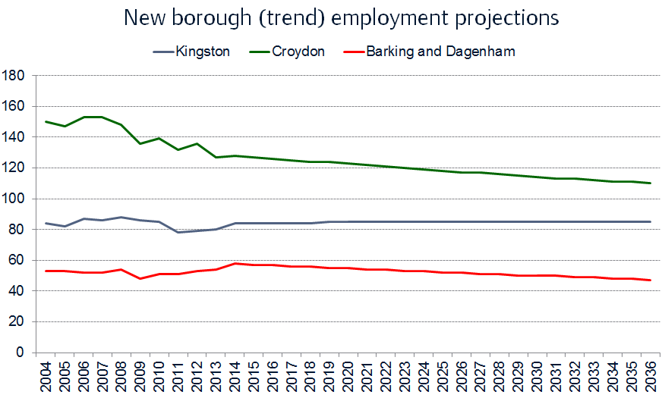

- How confident can we be in the projections? Some ‘alternative scenarios’.
There is as yet no real understanding of the puzzle suggesting no real recovery although 2011 was on trend with the central growth assumption of 5.73. The London employment rate is 72% at present – the highest since the 1980s ad the unemployment rate is accordingly quite low such that the labour market looks quite tight, which is not implausible. (The low growth rate may reasonably be discounted). An alternative methodology applies the same rates but to population projections. This would result in a projected employment level of 35,000 by 2036.

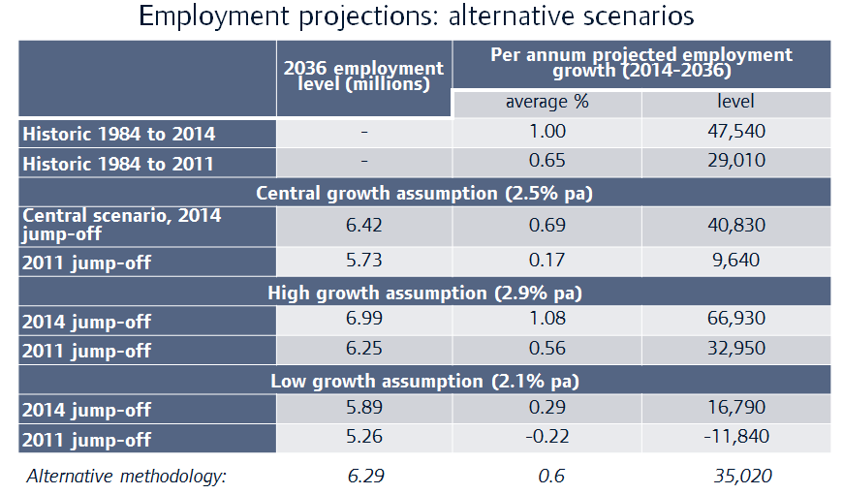

The present FALP assumes rises to 7m jobs with the current level at 6.4 although these are not yet final.So there is an increased level of uncertainty at the moment as to the likely future path of productivity – which makes projecting employment more difficult than usual;
But some initial analysis suggests this may be an ‘exceptional’ period – so more reason to monitor developments;
And we have had ‘similar’ uncertainties in the past.

- Conclusions
- Projections based on this methodology have performed well in the past;
- Recent employment growth has been exceptional – leading to the ‘productivity puzzle’ – causing problems for many forecasters;
- New employment projections show a significant uplift in jobs (due to ‘lost productivity’). Scenarios and an alternative methodology suggest the new level may not be unreasonable.
- But we will need to monitor developments (as are other bodies) in considering what projections to use for the new London Plan.

Discussion
Brian Waters thanked MW for a very clear presentation.
Michael Edwards amplified the proposition that the variable is trying to predict the numbers employed rather than population.

MW explained that the primary source for this work is Charles Ben and stems from the most recent Review of ONS statistics. The productivity puzzle, though not perhaps such a great one has not been fully explained. It is speculated that there is labour hoarding by London firms to guarantee the talent remains when productivity returns.
John Lett said the FALP is likely to adopt the central scenario of 40,830 as the most realistic. Population is more central to the FALP than employment. It is being assumed that growth is at 20,000 a year .

ME said that none of the scenarios has the assumption that productivity remains static, which would be a more dire prediction. Part of the problem is that labour costs have not grown but there is a huge surge in benefits so why should employers seek employment saving methods. He suggested that allowing wage increases or reducing subsidies might be preferable. Investment is currently low.

Tom Ball asked what has happened to manufacturing?
MW said the only sector of manufacturing that is increasing is food manufacturing. Part of the problem is that manufacturing is land hungry and the pressure is to use land for housing.
LF said that some of the definitions are out of date. For example manufacturing in Westminster is classified as design. There is a new class of modern manufacturing. Dyson separates this area of employment into concept and design, manufacturing and marketing and distribution.

DB said that much “manufacturing” is no longer producing physical products; it is no longer metal bashing.

JL said that this is not as serious as it sounds given that London is now a service driven economy although we are letting go from manufacturing some 3 times the amount of land we should. This results for example in Tower Hamlets of breaks in supply chains.

LF said that wages in UK are now second only to US. She asked that if there are to be in excess of 6 million jobs where they would be housed. It is necessary to look at projections inclusive of capacity when there is 80,000 square metres of employment floorspace being lost.

ME said there were clearly some big structural changes in employment including the release of former industrial land, the redevelopment of town centres to produce more housing at the expense of making and repairing in the backland behind town centres.

BW would include in this the growth in self-employment, notably home working accounting for 25% of employment floorspace.

- Minutes of the Meeting held on Monday 29th June 2015 at University College London in the Wilkins Garden Room* in the ground floor of the main building of UCL in Gower Street WC1E 6BT from 2.30-5.30pm Our hosts were Jessica Ferm and Nina Jaselik acting for Michael Edwards (who was lecturing abroad).
Agreed.

- Treasurer’s report.
Subscriptions are shortly to be issued at the same rate as the previous year.

- Next Meeting: Monday 7th December 2015 2.30pm at Colliers International 50 George Street London W1U 7GA. Host Jonathan Manns. It was conjectured that one of the Think Tanks could be invited to the next meeting.
- Review of standing items.
- AOB
The annual meeting of National Planning Forum and Cambridge University Land Society is due to be held at Dentons in April 2016

DR/dbm 23.9.15

